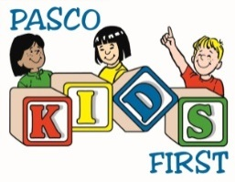
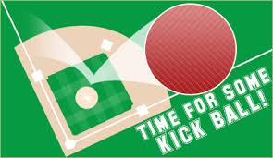
2nd ANNUAL PASCO KIDS FIRST
MIDDLE SCHOOL KICKBALL RETURNS
Presented by: Faux Iron Studions

May 9th – Schwettman Education Center and Gulf High Fields

Sponsorship & Marketing Opportunities

Presenting Sponsor – SOLD – FAUX IRON STUDIOS
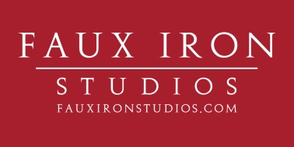

_______ Award Sponsor - $300.00
- 1 Team in Tournament
- Company banner at both fields (provided by sponsor)
- Company recognition as award sponsor on social media & press releases
- Logo on Pasco Kids First Website

_______ Team with Company Banner at Field - $200.00
- 1 Team in Tournament
- Banner provided by sponsor and displayed at field of choice

_______ Team - $120.00 (32 Teams Maximum)
- Team of 10 – 12 players (minimum of 4 women)

________ Banner at 1 Field - $100.00
- Banner provided by sponsor displayed at field of choice

Company/Team Name: ________________________________ Contact Person: _____________________

Email: ____________________________________________ Phone: ____________________________
To secure your sponsorship, send payment and this form to Becky Bennett at 7344 Little Road, New Port Richey, FL 34654. Checks made payable to: Pasco Kids First
Proceeds benefit Pasco Kids First, a 501c3 private, not-for profit organization with the mission to assist in the protection of children from the devastating effects of abuse and neglect. For more info contact Becky at 727-967-7509 or info@pascokidsfirst.org.
Come out, have fun and re-live the playground glory days!

