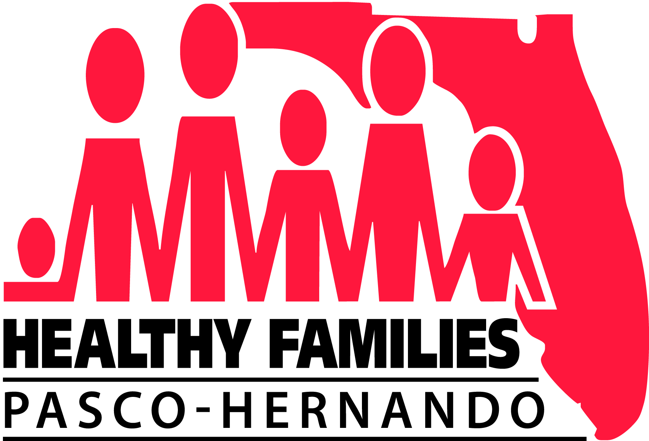
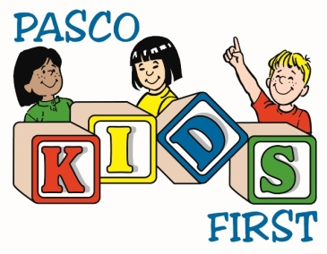
Oral Health
Navigation Program

WHO: Families participating in the Healthy Families Pasco-Hernando Program or receiving services at the Pasco Kids First Children’s Advocacy Center

WHAT: 1½ hour home visit by Julissa - Your Oral Health Navigator
- Goody bag of oral health supplies & resources for your family

- Interactive, fun presentation of dental facts that can help you teach your children how to have healthy teeth

- Connect you and your kids to dental providers

- Transportation assistance to dental appointments

WHERE: In the comfort and privacy of your own home

WHEN: Flexible appointment times based on your families availability

WHY: “Healthy Mouth Leads to a Healthy Body”
- Tooth decay and oral diseases are preventable
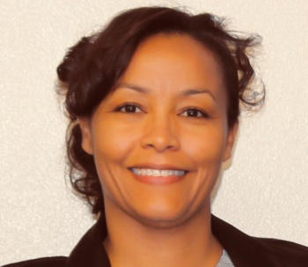
- 51 million school hours and 164 million work hours are missed each year due to tooth pain and dental issues

HOW: Contact Julissa Cantillo at 727-597-2508 to schedule your oral health home visit.

This program was funded by a grant from the Florida Blue Foundation.

