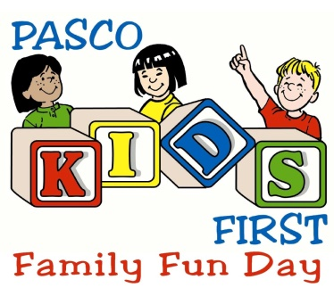

Dear Community Partner,

Pasco Kids First is excited to announce their 10th Annual Pasco Kids First Family Fun Day, to be held on Saturday, November 4, 2017 in Sims Park, New Port Richey. This event is designed to bring together a healthy place for families to have fun, while learning about the different programs in our county that are in place to keep kids and families safe. For the past eight years, this event was a huge success, bringing together more than 3,000 attendees, and we are once again looking forward to bringing this community favorite event on November 4th.

We hope that you will consider joining us at our event this year as we once again bring this event to the children and families of our community. Some of our partners since the inception of the event include Pasco County Sheriff’s Office, Pasco Department of Health, New Port Richey Police and Fire Department who are already signed up again this year.

I have enclosed our vendor application for this year’s event. Please take a few minutes to fill out the application and fax or mail it back to us so that we can secure your spot in this year’s event. If you have any questions about vendor spaces, please feel free to contact me at any time at (727) 835-7962 ext. 24.

We look forward to seeing you at our event this year!

Sincerely,

Becky Bennett

Becky Bennett
Director of Development
Pasco Kids First Family Fun Day

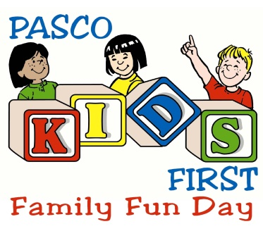
Vendor Application
Saturday, November 4, 2017
10:00 a.m. – 3:00 p.m.

NAME: _______________________________________ HOME PHONE: ( ) __________________

DBA or BUSINESS NAME: ______________________________________________________________

ADDRESS: __________________________________________________________________________
CITY: _________________________________________ STATE: ________ ZIP CODE: ___________

DAY TIME PHONE: ( ) ________________________ FAX: ( ) ___________________________

E-MAIL: _____________________________________________________________________________

DESCRIPTION OF BOOTH ITEMS:
Vendors are required to provide an activity with the kids such as crafts or games and make their booths interactive (please no booths that just pass out fliers).

____________________________________________________________________________________

PRICE RANGE OF ITEMS (If applicable): __________________________________________________

PLEASE INDICATE WHAT BEST DESCRIBES YOUR SET-UP: PLEASE INCLUDE DIMENSIONS

[ ] BOOTH __________________ [ ] TENT ___________________ [ ] TRAILER ______________

[ ] OTHER (explain): __________________________________________________________________

DO YOU REQUIRE ELECTRICITY: [ ] YES [ ] NO

Event Fees:
Pasco Kids First Family Fun Day (November 4th from 10:00 a.m. – 3:00 p.m.)

Registration Fee
________ $100.00* - For Profit Vendors / Businesses

________ $50.00* – Non-Profit Vendors (501(c)3, 501(c)4, and 501(c)6 designation)

*Registration fee is just for booth space and does not include tables and chairs, or other items needed for your booth. Vendors are responsible for providing tables, chairs, and other items for their booth.

*If you need Pasco Kids First Family Fun Day to provide you a table, the table fee is an additional $20.00 per table (includes 2 chairs) and must accompany this application a minimum of 20 days prior to the event.

_________ - # Tables needed - $25 each includes 2 chairs

APPLICATION DEADLINE: OCTOBER 13, 2017. ALL APPLICATIONS AND PAYMENT ARE TO BE TURNED IN TO PASCO KIDS FIRST BY FRIDAY, OCTOBER 13th AT 5:00 PM.

Rules & Regulations:
$100.00 For-Profit / $50.00 Non-Profit Registration Fee is non-refundable.

$25.00 Table Fee – per table rented (optional) is non-refundable.
Logistics and Requirements:
Pasco Kids First reserves the right to refuse admittance to any vendor whose product / work is deemed offensive or of questionable taste.

Event is to be held rain or shine. Not refunds. No rain dates.

Each participant is responsible for collecting Florida State sales tax and reporting it to the Florida Department of Revenue (if applicable).

Each participant is responsible for their own display and must be open during advertised hours of event.

All participants must be pre-registered, no exceptions.

Spaces may not be shared.

SET-UP: Rules and set up logistics will be sent with a vendor confirmation package approximately one week prior to the event.

BREAK DOWN AND CLEAN UP: Vendors may not break down their booth or close up prior to the event ending at 3:00 p.m. Vendors who leave the event prior to the 3:00 p.m. closing time jeopardize their opportunity to participate in future Pasco Kids First events, including future Family Fun Day events.

Booths, tents, displays, trash, etc. left until the next day may be charged a substantial additional amount in clean up fees and / or penalties. Clean up of booths and surrounding areas is the responsibility of the vendor. Any clean up by the City of New Port Richey, or an agent of Pasco Kids First, is charged at a minimum rate of $25.00 per hour with a 4 hour minimum.

INSURANCE: Upon signing this agreement, the Event Host shall provide Pasco Kids First, Inc. a certificate of Commercial General Liability insurance that includes Bodily Injury, Property Damage and Non Owned & Hired Auto coverage with a minimum liability amount of $500,000 naming Pasco Kids First, Inc. and the City of New Port Richey as additional insured.

GENERAL RELEASE: (Must sign and return with each application)
I (please print name)_____________________, agree to the rules stated in this agreement between myself and PASCO KIDS FIRST. I also agree to indemnify, defend, and hold harmless PASCO KIDS FIRST, the CITY OF NEW PORT RICHEY, any and all SPONSORS, and any and all members or agents from all claims, injuries, damages or actions caused or suffered by the exhibitor arising out of the activity or participation of the exhibitor in connection with the above mentioned event, except for any claim, injury, damage or action caused wholly or in part by PASCO KIDS FIRST, the CITY OF NEW PORT RICHEY, any and all SPONSORS, and any and all members or agents negligence. I also as the exhibitor agree to save and hold harmless PASCO KIDS FIRST, the CITY OF NEW PORT RICHEY, any and all SPONSORS and any and all members or agents, for the damage of or loss of personal property and or effects of the exhibitor stored, used or sold during the activity which the exhibitor was in participation in.

APPLICANTS SIGNATURE_________________________________________ DATE_______________

Mail Application and a check for the registration fee to:

Pasco Kids First
Attention: Family Fun Day
7344 Little Road
New Port Richey, Florida 34654

Selection of vendors is at the sole discretion of Pasco Kids First.
Confirmed vendors will be notified by email/mail.

