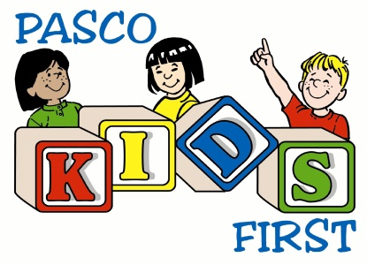

Dear Community Business Leader,
Pasco Kids First is excited to announce their 10th Annual Pasco Kids First Family Fun Day, to be held on Saturday, November 4, 2017 in Sims Park, New Port Richey. This event is designed to bring together a place for families to have fun, while learning about the different programs in our county that are in place to keep kids and families safe. For the past nine years, this event was a huge success, bringing together more than 3,000 families, and we are once again looking forward to bringing this community favorite event on November 4th.
This year, we are again seeking support from our business community to put this event on for the families in Pasco and Hernando Counties, and beyond. We recognize that you are asked repeatedly to help support various activities and events in the community. We think you will find this event to be especially important because of the impact that it has on our area families and the numerous benefits this event offers for your company.
Enclosed, is our sponsorship packet which includes an overview of our event, copies of previous event promotion, sponsorship levels, and an application for sponsorship. These sponsorship levels show some of the benefits that our sponsors receive by being a part of our event. Please note that while we have provided an outline for each sponsorship level, that each level can also be tailored to meet your marketing needs. We welcome your input as to what type of promotion would be best for your business as you become a part of this year’s event.
I look forward to speaking with you further regarding our sponsorship opportunities, and look forward to having you as a part of our event this year.
Should you have any questions, please feel free to contact me at any time at (727) 835-7962, ext. 24.
Sincerely,
Becky Bennett
Becky Bennett
Director of Development
Pasco Kids First

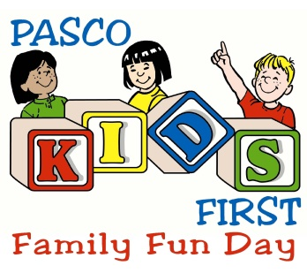
10th Annual Pasco Kids First Family Fun Day
2017 Sponsorship Levels

$5,000 – Presenting Sponsor (1 sponsorship available)
Our Presenting Sponsorship is the highest sponsorship level that is available for Family Fun Day. This sponsor receives top billing rights at the event, with the event title reading, “Pasco Kids First Family Fun Day presented by….). This sponsorship offers the most exposure opportunities of all the sponsorships.
- Mentioned as overall event sponsor of event (presented by….) in all publicity for event (incorporated into event logo that will appear on all advertising and promotion developed for event)
- Logo on event fliers as presenting sponsor (approximately 14,000)
- Logo on 2 event banners – displayed approx. 1 week prior to event
- Presenting sponsor mention in all press releases
- On-site vendor space
- 4 banners at event (to be provided by sponsor)

$2,500 – Advocate
Our Advocate Sponsorship is a great opportunity for companies that would like logo exposure on all of the Family Fun Day event publicity. Other than the presenting sponsorship, this is the only sponsorship that guarantees logo placement on app marketing and promotional materials. In addition, one component of the event will include the advocate as the presenting sponsor. Several opportunities for sponsorship at the Advocate level are available.
- Logo on event fliers (approximately 14,000)
- Sponsor mention in all press releases
- Component sponsor (Health Walk, Entertainment (DJ), Ropes Course, Touch-a-Truck; name to be included at location of activity with sign provided by event)
- Sign (approximately 2) at activity
- On-site vendor space at event
- 2 banners at event (to be provided by sponsor)

$1,000 – Partner
Our Partners at Family Fun Day will receive name mentioning on all promotional items generated for the event. They also have the opportunity to be named as a sponsor of one small activity within the event. These include one of the inflatables, prizes sponsor, etc. Several sponsorships are available at this level.
- Name on event fliers (approximately 14,000)
- Activity sponsor (1 Inflatable, Bikes Sponsor – prize from Health Walk; name to be included at location of activity with sign provided by event)
- Sponsor mention in all press releases
- On-site vendor space at event
- 1 banner at event (to be provided by sponsor)

$500 – Supporter
Our Supporters receive their name on all fliers generated for Family Fun Day. In addition, to increase exposure for our supporters, they will have the opportunity to have a booth on site, and can provide the event with a banner to be displayed for added exposure. There are an unlimited number of sponsorships available at the Supporter level.
- Sponsor mention in all press releases
- Name mention on Event fliers (approximately 14,000)
- On-site vendor space at event
- 1 banner at event (to be provided by sponsor)

$500 – Volunteer Hospitality Sponsor (1 sponsorship available)
The Volunteer Hospitality Sponsor is our exclusive sponsor of our volunteer hospitality. At Family Fun Day, we have approximately 100 volunteers that we provide snacks and beverages for. This sponsorship is crucial for us to be able to provide beverages and snacks to those who help with our event. Our Volunteer Hospitality Sponsor will receive their name on all fliers generated for Family Fun Day. In addition, to increase exposure for our supporters, they will have the opportunity to have a booth on site, and can provide the event with a banner to be displayed for added exposure. There is only one sponsorship available for Volunteer Hospitality.
- Sponsor mention in all press releases
- Name mention on Event fliers (approximately 14,000)
- On-site vendor space at event
- 1 banner at event near stage and volunteer hospitality area (to be provided by sponsor)

$250 – Friend
Our Supporters receive their name on all fliers generated for Family Fun Day. In addition, to increase exposure for our supporters, they will have the opportunity to have a booth on site, and can provide the event with a banner to be displayed for added exposure. There are an unlimited number of sponsorships available at the Supporter level.
- Name mention on Event fliers (approximately 14,000)
- On-site vendor space at event
- 1 banner at event (to be provided by sponsor)

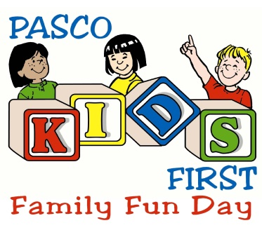
Sponsorship Application
Saturday, November 4, 2017
10:00 a.m. – 3:00 p.m.

NAME: _______________________________________ HOME PHONE: ( ) __________________
DBA or BUSINESS NAME: ______________________________________________________________
ADDRESS: __________________________________________________________________________
CITY: _________________________________________ STATE: ________ ZIP CODE: ___________
DAY TIME PHONE: ( ) ________________________ FAX: ( ) ___________________________
E-MAIL: _____________________________________________________________________________
Sponsors – Please include your logo, in electronic format.
PLEASE email your logo to bbennetthfpasco@aol.com as soon as your sponsorship agreement is signed and returned.
SPONSORSHIP LEVEL (please check one):
_________ $5,000 Presenting Sponsor
_________ $2,500 Advocate Sponsor
_________ $1,000 Partner Sponsor
_________ $500 Supporter Sponsor
_________ $500 Volunteer Hospitality Sponsor
_________ $250 Friend Sponsor

*Each sponsorship includes a vendor space at event, table, and two chairs. If additional tables and chairs are needed, please let Pasco Kids First know at least 2 weeks prior to event.
GENERAL RELEASE: (Must sign and return with each application)
I (please print name), ____________________________________ agree to the rules stated in this agreement between myself and PASCO KIDS FIRST. I also agree to indemnify, defend, and hold harmless PASCO KIDS FIRST, the CITY OF NEW PORT RICHEY, any and all SPONSORS, and any and all members or agents from all claims, injuries, damages or actions caused or suffered by the exhibitor arising out of the activity or participation of the exhibitor in connection with the above mentioned event. I also as the exhibitor agree to save and hold harmless PASCO KIDS FIRST, the CITY OF NEW PORT RICHEY, any and all SPONSORS and any and all members or agents, for the damage of or loss of personal property and or effects of the exhibitor stored, used or sold during the activity which the exhibitor was in participation in.
APPLICANTS SIGNATURE_________________________________________ DATE_______________
Mail Sponsorship Application to:
Pasco Kids First
Attention: Family Fun Day
7344 Little Road
New Port Richey, Florida 34654

